Shuttle buses will be going from the Lower Makefield Township complex (~3 miles away) to our venue. It is advised that you consider meeting there and dropping off cars then car pooling to the park with the passes provided. This allows the people leaving their cars to be able to get back to them on the buses if needed.
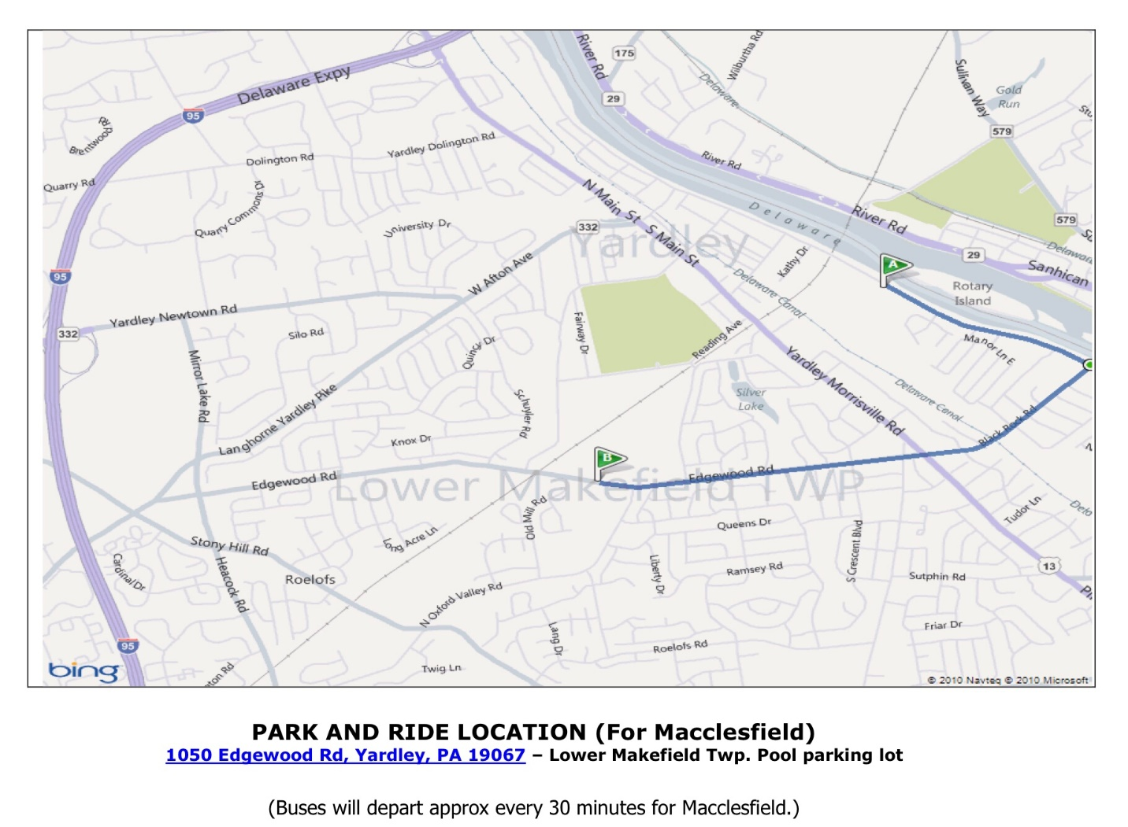
From North: I-95 S into PA to exit 51A toward Yardley. Merge onto Taylorsville Rd. Continue onto N Main St. Turn right onto PA-332 W/W Afton Ave. At the light at the top of the hill, turn left onto Schuyler Dr. At the end of Schuyler Dr., turn left onto Edgewood Rd. Pass over train tracks, and the parking lot will be on the left after you pass baseball fields on the right.
From South: I-95 N to exit toward PA-332 E/Yardley Newtown Rd. Turn right onto PA-332 E/Yardley Newtown Rd. Continue through light onto Schuyler Dr. At the end of Schuyler Dr., turn left onto Edgewood Rd. Pass over train tracks, and the parking lot will be on the left after you pass baseball fields on the right.
From Macclesfield Park: Turn right onto River Rd. Pass Manor Ln. and Bedford Pl. and then turn right onto Black Rock Road. Continue straight onto Edgewood Rd. After the 3rd stop light, turn right into to parking lot for the LMT pool.
From PA Turnpike: Take exit 351 to merge onto US-1 N. Take the exit onto I-95 N. Take exit toward PA-332 E/Yardley Newtown Rd. Turn right onto PA-332 E/Yardley Newtown Rd. Continue through light onto Schuyler Dr. At the end of Schuyler Dr., turn left onto Edgewood Rd. Pass over train tracks, and the parking lot will be on the left after you pass baseball fields on the right.

